**INTRODUCTION**

A light sensor is a crucial electronic component that detects and measures the intensity of ambient light in its surroundings. This device utilizes various technologies, such as photodiodes or phototransistors, to convert light energy into an electrical signal. Light sensors play a vital role in numerous applications, including automatic brightness control in displays, outdoor lighting systems, and environmental monitoring. These sensors are instrumental in optimizing energy efficiency and enhancing the performance of devices by adapting to changing light conditions. Their versatility makes them indispensable in diverse fields, from consumer electronics to industrial automation.

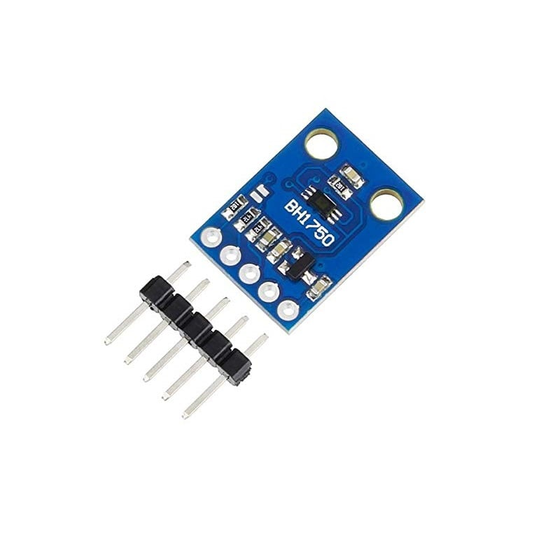 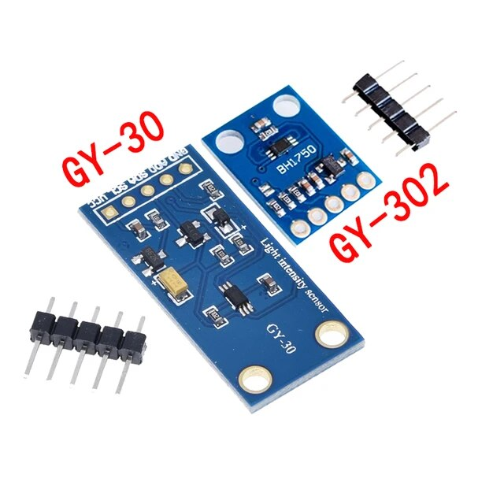

**Specification: -**

* Operating Voltage: 2.4 – 3.6V
* Operating Current: 0.12mA
* Communication Protocol: I2C
* Temperature: -40°C to 85°C
* Clock frequency: 400kHz
* Range: -1 – 65535 LUX
* Light Noise Rejection-Function: 50Hz/60Hz
* Minimum I2C reference voltage: 1.65V

**BH1750 Pinout**

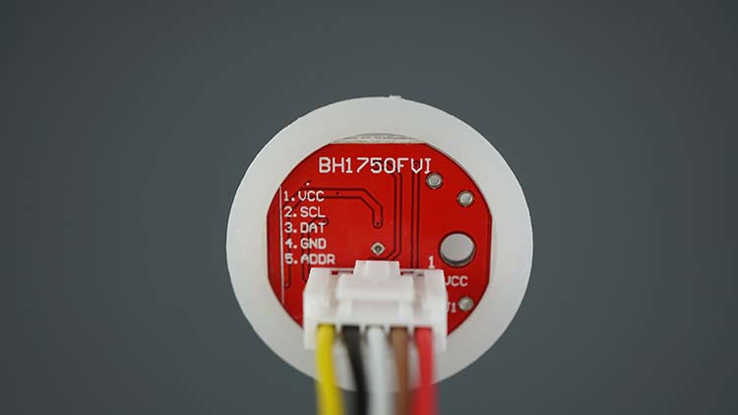 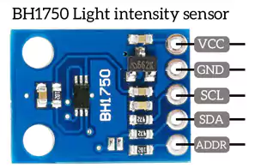

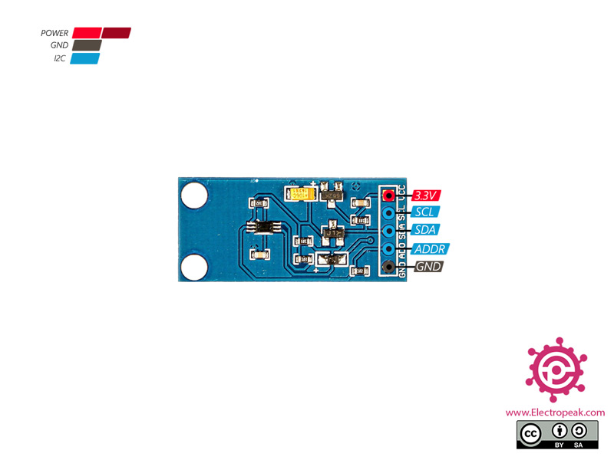

**VCC –** is the power supply pin. The supply Voltage is in the range of 2.4v – 3.6v.

**GND -** is the ground pin. This pin is connected to the ground of the circuit.

**SCL -** is the Serial Clock Line. This pin is used to provide a clock pulse for I2C communication between the sensor and the microprocessor.

**SDA –** is the Serial Data Address. This pin is used by I2C communication to transfer the data from the sensor to the microprocessor.

**ADDR –** is the Device Address Pin. This pin is used when more than one module is connected, for selecting the address.

* ADD pin floating or connected to GND → address: 0x23
* ADD pin connected to VCC → address: 0x5C

**Alternative IC**

* Some of the IC that can be used as an alternative to BH1750 are TSL2561, VEML6035.
* Some of the other types of light sensors are the LDR sensor and TCS3200.
* Nowadays BH1750 is highly used for applications such as LCD displays, Note PC, Portable game consoles, Digital camera, PDA, LCD TV, etc.... to provide high user experience to the customer.
* Cell phones contain BH1750 to adjust the brightness of the screen according to the external light conditions.
* BH1750 is also used to control the turning ON/OFF the automatic streetlights.
* BH1750 is used to adjust the keyboard backlight in smartphone.

**What is BH1750?**

The BH1750 serves as a Digital Ambient light sensor, effortlessly interfacing with microcontrollers through the I2C communication protocol. Known for its low power consumption, this sensor utilizes a photodiode with a PN Junction to generate electron-hole pairs in the depletion region when exposed to light. The resulting electric charge, proportional to light intensity, is transformed into voltage by an Op-Amp. This efficient conversion mechanism facilitates precise light intensity measurements in various applications. This IC is best suited to get the ambient light data in mobile phones to manipulate the screen brightness based on the environment lighting. This sensor can accurately measure the LUX value of light up to 65535.

**Schematic Diagram**

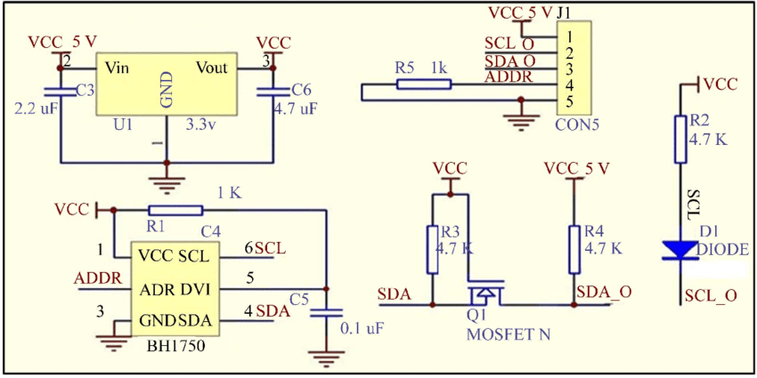

The BH1750 operates within a voltage range of 2.4V to 3.6V, with the main module, BH1750FVI, requiring a 3.3V supply. To ensure compatibility, a voltage regulator is incorporated in the circuit. The I2C communication is facilitated through the SDA and SCL pins, each equipped with 4.7kΩ pull-up resistors. The device's address is contingent on the logic state of the address pin, which defaults to the low address (0x23) when not connected. By closing PCB jumper J1, the address pin is pulled high, configuring the address as 0x5C. Alternatively, the address can be controlled via an input signal on the ADD pin with J1 open. The DVI pin features an RC delay for proper power-on reset, and the module provides easy integration with microcontrollers through a breadboard-compatible berg strip. This design enhances accessibility and seamless interfacing with devices like Arduino.

**Measurement Modes**

The sensor supports two different measurement modes: Continuous measurement mode, and one time measurement mode. Each mode supports three different resolution modes.

|  |  |  |
| --- | --- | --- |
| Low Resolution Mode | 4 lux precision | 16ms measurement time |
| High Resolution Mode | 1 lux precision | 120ms measurement time |
| High Resolution mode 2 | 0.5 lux precision | 120ms measurement time |

In Continuous measurement mode, the sensor continuously measures ambient light values. In one-time measurement mode, the sensor measures the ambient light value once, and then it goes to power down mode.

**Wiring BH1750 with Arduino Uno**

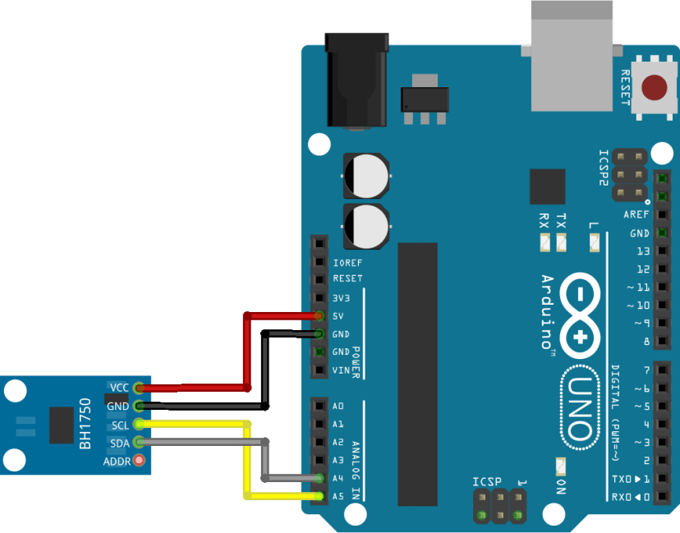

|  |  |
| --- | --- |
| **BH1750** | **Arduino** |
| VCC | 5V |
| GND | GND |
| SCL | A5 |
| SDA | A4 |
| ADD | Don’t connect |

By not connecting the **ADDR**pin, we’re selecting 0x23 I2C address. Connect it to 3.3V to select 0x5C address instead.

**Installing the BH1750 Library**

Open your Arduino IDE and go to Sketch > Include Library > Manage Libraries. The Library Manager should open.

Search for “BH1750” on the search box and install the BH1750 libraries.

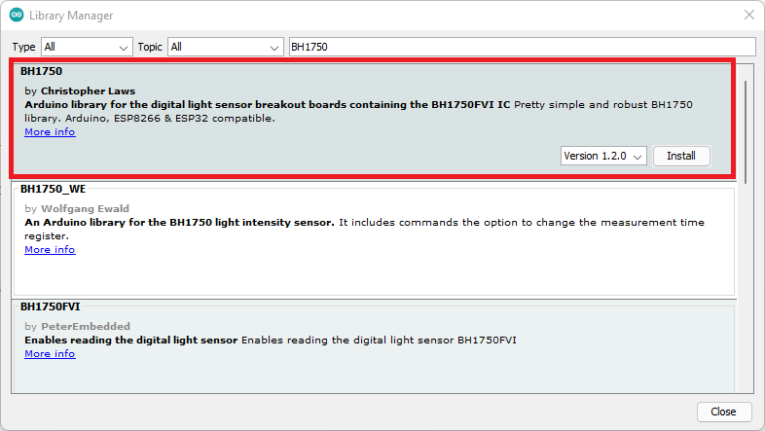

**Code:**

#include <Wire.h>

#include <BH1750.h>

BH1750 lightMeter;

void setup(){

Serial.begin(9600);

// Initialize the I2C bus (BH1750 library doesn't do this automatically)

Wire.begin();

// On esp8266 you can select SCL and SDA pins using Wire.begin(D4, D3);

// For Wemos / Lolin D1 Mini Pro and the Ambient Light shield use Wire.begin(D2, D1);

lightMeter.begin();

Serial.println(F("BH1750 Test begin"));

}

void loop() {

float lux = lightMeter.readLightLevel();

Serial.print("Light: ");

Serial.print(lux);

Serial.println(" lx");

delay(1000);

}

**OUTPUT:**

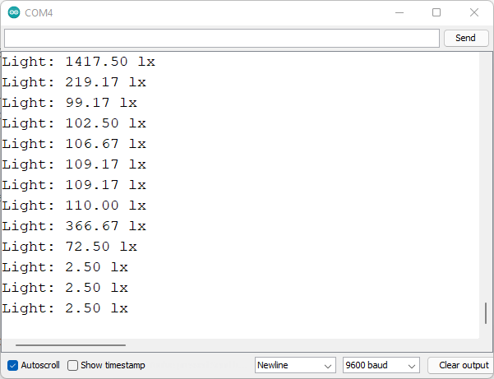

**Code Explanation:**

* The Wire.h library to use I2C communication protocol and the BH1750.h library to read from the sensor.

#include <Wire.h>

#include <BH1750.h>

* We have created a BH1750 object called lightMeter.

BH1750 lightMeter;

* In the setup(),initialize the serial monitor at a baud rate of 9600.

Serial.begin(9600);

* Initialize I2C communication protocol. It will start an I2C communication on the microcontroller’s default I2C pins. If you want to use different I2C pins, pass them to the begin() method like this Wire.begin(SDA, SCL).

Wire.begin();

* Initialize the sensor using the begin() method on the BH1750 object (lightMeter).

lightMeter.begin();

* In the loop(), we create a variable called lux, that saves the luminance values. To get the value, you simply call the readLightLevel() function on the BH1750 object (lightMeter).

float lux = lightMeter.readLightLevel();

* Finally, display the measurement on the Serial Monitor.

Serial.print("Light: ");

Serial.print(lux);

Serial.println(" lx");

* You get and print a new reading every second.

delay(1000);

**Setting Measurement Mode**

By default, the library uses the continuous high resolution measurement mode, but you can change it by passing the desired measurement mode to the begin () method when initializing the sensor. For example:

lightMeter.begin(BH1750::CONTINUOUS_HIGH_RES_MODE)

Here’s a list of all available modes:

* BH1750_CONTINUOUS_LOW_RES_MODE
* BH1750_CONTINUOUS_HIGH_RES_MODE (default)
* BH1750_CONTINUOUS_HIGH_RES_MODE_2
* BH1750_ONE_TIME_LOW_RES_MODE
* BH1750_ONE_TIME_HIGH_RES_MODE
* BH1750_ONE_TIME_HIGH_RES_MODE_2

**BH1750 Light Sensor with ESP8266 (NodeMCU)**

Now how to use it with an ESP board? Since the ESP8266 has i2c pins on D1 and D2 so just connect the SCL to D1 and SDA to D2. This sensor module also works fine with a 3V power source. So just connect the VCC to 3V and GND to GND.

**BH1750 Wiring Diagram with ESP-board (NodeMCU)**

